
A TECHNICAL REPORT ON
STUDENTS' INDUSTRIAL WORK EXPERIENCE SCHEME (SIWES)
UNDERTAKEN AT

GYB CONSULTS LIMITED.

No. 69B, Akinola Cole Crescent, off Adeniyi, Ikeja, Lagos State.

COMPILED BY:
OLADIRAN OLUWASHINA GABRIEL
ARC/22/0604

SUBMITTED TO:
THE DEPARTMENT OF ARCHITECTURE, SCHOOL OF ENVIRONMENTAL TECHNOLOGY,
FEDERAL UNIVERSITY OF TECHNOLOGY, AKURE.

CERTIFICATION
This is to certify that the accompanying report is a complete account of the Student Industrial Work Experience Scheme (SIWES) undertaken by OLADIRAN OLUWASHINA GABRIEL with matric number ARC/22/0604, at GYB Consults Nigeria Limited, for the period 1st June, 2026 – 17th October 2026, in accordance with the regulations guiding the Department of Architecture, Federal University of Technology, Akure, in partial fulfilment of the requirements for the award of a Bachelor of Technology in Architecture.

………………………………. ………………
Name of Student Signature & Date

……………………………….. …………………
Industrial-based Supervisor Signature & Date

DEDICATION
I dedicate this report, and the season of growth it represents, first and foremost to God Almighty, the source of every ounce of strength, clarity, and grace that carried me through this training. In the moments when I felt out of my depth, on site or in the studio, it was His guidance that steadied me, and for that I am endlessly thankful.
To my parents, whose sacrifices laid the very foundation of everything I have been able to achieve, thank you for believing in me long before I believed in myself, and for the quiet, steady support that never once wavered, even when this journey demanded more of you than words can fully capture. Every drawing I produced and every site I visited during this training carries a piece of what you have poured into me.
To my siblings, thank you for the laughter, the encouragement, and the simple reassurance of knowing I never had to walk this road alone. Your presence in my life has been a gift I do not take for granted.
To everyone at GYB Consults Nigeria Limited, from the Managing Director down to every staff member and other intern students who took the time to explain, correct, and guide me, thank you for opening your firm to me and treating my learning as something worth investing in. This training could easily have been a formality; instead, it became a genuinely transformative chapter of my journey, and I dedicate this report to that experience and to everyone who shaped it.
Finally, to every student who will one day pick up a report like this one and begin their own SIWES journey, may you find, as I did, that the effort is always worth it.

ACKNOWLEDGEMENT
I am deeply grateful to God Almighty for granting me the strength, wisdom, and good health needed to complete this Student Industrial Work Experience Scheme (SIWES) successfully. My heartfelt appreciation goes to my parents and family for their constant encouragement, prayers, and support throughout this journey.
I extend my sincere gratitude to the management and staff of GYB Consults Nigeria Limited for providing me with a rich and instructive learning environment. Special thanks go to the Managing director, Arc. Gbenga Onabanjo, and the firm's Associate Partners, Arc. Joseph Babatunde and clerk of works Arc. Ajibola Olayemi, for their leadership and for creating a firm culture where interns are genuinely mentored rather than simply assigned tasks. I am also thankful to the Structural engineers , Engr. Eniola Hermes, Engr. Idowu Stephen, Engr.Ogunbode Pipeoluwa and the wider architectural and quantity surveying staff for their patience and willingness to explain the reasoning behind their work whenever I asked.
My particular thanks go to my industrial-based supervisor, Arc. Ajibola Olayemi, whose mentorship, patience, and hands-on guidance shaped much of what I now understand about professional architectural practice. Finally, I acknowledge the Department of Architecture, Federal University of Technology, Akure, for structuring this program and giving me the opportunity to participate in it.

ABSTRACT
This report documents the knowledge and practical experience acquired during my Student Industrial Work Experience Scheme (SIWES), undertaken over a period of five[5] months/Twenty[20] at GYB Consults Nigeria Limited, an indigenous architectural consulting and construction firm based in Adeniyi jones, Ikeja, Lagos State.
The report is organized into five chapters. Chapter One introduces the SIWES program and its objectives. Chapter Two presents the profile, history, services, and structure of GYB Consults Nigeria Limited. Chapter Three covers my construction site experience, foundation excavation, reinforcement, blockwork, laterite filling and compaction, spanning setting-out, beams and columns, building renovation, and attendance at site and project meetings across sites in Oregun, Victoria Island, kobape and ijebu ode (Ogun State)
Chapter Four details my studio-based experience, covering the design software used at the firm, AutoCAD, Revit, and Lumion, and the specific projects I contributed to, including a re-design of a residential building
Chapter Five summarizes the skills acquired, challenges encountered, and recommendations for strengthening the program, before concluding with a reflection on how the training bridged the gap between classroom theory and professional architectural practice.

TABLE OF CONTENTS
CERTIFICATION …………………………………………………………………………… DEDICATION ………………………………………………………………………………. ACKNOWLEDGEMENT …………………………………………………………………… ABSTRACT ………………………………………………………………………………….
CHAPTER 1 …………………………………………………………………………………
1.0 Introduction ……………………………………………………………………………..
1.1 Background of the Industrial Training Fund (ITF) …………………………………..
1.1.1 Functions of the Industrial Training Fund …………………………………………
1.2 Overview of SIWES ………………………………………………………………….. 1.3 Aims and Objectives of SIWES ………………………………………………………
1.4 Growth of the Scheme ………………………………………………………………..
1.5 Scope of the Scheme …………………………………………………………………
1.6 Roles of Stakeholders in the SIWES Program …………………………………….
CHAPTER 2 ………………………………………………………………………………..
2.0 Company Profile: GYB Consults Nigeria Limited ………………………………….
2.1 History/Background of the Company ………………………………………………
2.2 Company Philosophy and Expertise ………………………………………………
2.3 Services and Areas of Specialization ……………………………………………..
2.4 Structure of the Company …………………………………………………………. 2.5 Professional Recognition and Regulatory Compliance …………………………
2.6 Notable Projects …………………………………………………………………….

CHAPTER 3 ………………………………………………………………………
3.0 Construction Site Experience ……………………………………………………
  - Overview of Site Works ………………………………………………………….
  - Casting ……………………………………………………………………………...
  - Formworks ………………………………………………………………………….
  - Raft Foundation ……………………………………………………………………
  - Building Renovation ……………………………………………………………….
  - Building Measurement Billing ….…………………………………………………
  - Reinforcement ………………………………………………………………………
  - Beams and Column .…………………………………………………………….
  - Concrete Quality Control ………………………………………………………….
3.10 Blockwork …………………………………………………………………………
3.11 Site Meeting………………….………………………………………………………
3.12 Construction Site Safety…….………………………………………………………

CHAPTER 4………………………………………………………………………………

4.1 AutoCAD …………………………………………………………………………….
4.2 Revit …………………………………………………………………………………
4.3 Lumion ………………………………………………………………………………
4.4 Theoretical Knowledge Gained During the Internship …………………………
4.4.1 Roles of Professionals in the Construction Industry …………………………
4.4.2 Project Management ……………………………………………………………
4.5 Studio Projects ……………………………………………………………………
- Ijebu-ode Duplex ………………………………………………………..
- 2 Bedroom Bungalow ………………………………………………………………
- Mansionette Building ……………………………………………………………
- AACE Admin Block ………………………………………………………………
CHAPTER 5 …………………………………………………………………………..
  - Summary of Training Experience ………………………………………………
  - Skills Acquired ………………………………………………………………………
  - Problems/Challenges Faced During Training ……………………………………
  - Recommendations ……………………………………………………………………
  - Conclusion …………………………………………………………………………….
  - References …………………………………………………………………………….

CHAPTER 1

1.0 INTRODUCTION
The effective education of students in tertiary institutions across diverse disciplines depends significantly on the integration of practical, hands-on experience alongside academic instruction. To facilitate this, the Students Industrial Work Experience Scheme (SIWES) serves as a crucial component, offering students a valuable opportunity to experience real-world work environments and apply their academic knowledge in practical settings. This experience enhances their productivity and readiness for the workforce upon graduation. Under this program, students are placed in relevant organizations within their respective fields for a defined training period, during which they are exposed to the day-to-day realities of professional practice and realities that a lecture hall, however well taught, cannot fully replicate.
This report provides a detailed account of my training experience at GYB Consults Nigeria Limited, with a focus on the methodologies, procedures, and technical aspects involved in architectural design and building construction. It spans both the studio and site dimensions of the firm's work, and highlights the challenges encountered during training, along with recommendations for potential improvements to the scheme.


1.1 BACKGROUND OF THE INDUSTRIAL TRAINING FUND (ITF)
The Industrial Training Fund (ITF) was established as a government agency with the primary aim of developing and training the Nigerian workforce, in line with post-independence initiatives for economic growth. The ITF's mandate was to foster a shift away from reliance on foreign expertise toward building a skilled, indigenous workforce capable of driving Nigeria's key economic sectors forward. Since its inception, the ITF has remained committed to this mission, consistently
working toward Nigeria's economic self-sufficiency through the development of local manpower.

1.1.1 FUNCTIONS OF THE INDUSTRIAL TRAINING FUND
The establishment decree of the ITF empowered a governing council to set policies and oversee the following responsibilities:
- Provide and support training facilities for employees.
- Approve training courses and facilities offered by employers.
- Regularly assess areas of industry requiring specialized manpower development.
- Recommend necessary training standards and ensure they are upheld.
- Assist individuals in locating training opportunities and securing industry employment.
- Conduct or support research into training requirements within various industry sectors.

1.2 OVERVIEW OF SIWES
The Students Industrial Work Experience Scheme (SIWES) was founded in 1973 by the ITF to bridge the gap between academic theory and real-world professional application. It was designed to help students acquire practical skills that complement the academic knowledge gained in higher institutions, ensuring they are well prepared to meet the demands of their chosen professions upon graduation. SIWES primarily targets students in fields such as Engineering, Environmental Technology, Sciences, Agriculture, Technical, and Business Studies, promoting close collaboration between academic institutions and industry so that students can develop competencies specific to their field of study.

1.3 AIMS AND OBJECTIVES OF SIWES
SIWES was established with the following goals:
- Bridging Theory and Practice: enabling students to apply classroom learning to practical work, linking academic knowledge with industry realities.
- Skill Development: offering students, particularly in engineering and related fields, the chance to gain practical skills and experience relevant to their studies.
- Employer Engagement: encouraging employer involvement in education, preparing students for successful careers in industry.
- Career Readiness: helping students transition smoothly from academic to professional environments by familiarizing them with actual work settings.
- Exposure to Advanced Tools: providing students access to equipment and methods not readily available at school, enhancing their technical knowledge.
- Increased Interest and Performance: cultivating students' enthusiasm and understanding of their disciplines through practical exposure, thereby improving academic performance.

1.4 GROWTH OF THE SCHEME
Since its inception, SIWES has steadily expanded in scope and reach. What began as a modest program involving a small number of institutions has grown over the decades to encompass a much wider network of universities, polytechnics, and colleges of education across Nigeria. As the country's industrial and construction sectors continue to develop, SIWES is expected to keep growing in relevance, supporting the evolving needs of the Nigerian workforce.

1.5 SCOPE OF THE SCHEME
SIWES requires a period of practical training for students in Engineering and related fields, typically undertaken during the third or fourth year of study. For architecture students at institutions such as the Federal University of Technology, Akure, this program is compulsory and forms a credit-bearing component of the curriculum, focused specifically on field experience. My own training at IBW Consults Nigeria
Limited spanned a period of five [5] months, from 1st of june, 2026 till 17th of October, 2026, during which I was exposed to architectural design, working drawings, computer-aided design, visualization, and construction/site-related activities.

1.6 ROLES OF STAKEHOLDERS IN THE SIWES PROGRAM
Role of the ITF: The ITF's responsibilities include supervising students on placement, organizing orientation programs, formulating SIWES policies, processing institutional placement lists, and coordinating the distribution of allowances to students and supervising staff.
Role of Institutions: Academic institutions play a key role by establishing SIWES coordination units, ensuring adequate funding and oversight, preparing specifications for accredited courses, and helping students secure suitable placements within their field of study.
Role of Coordinating Units: Coordinating units appoint full-time industrial coordinators, establish minimum guidelines for placement and supervision, and oversee SIWES activities to ensure successful execution of the program from placement through to reporting.

CHAPTER 2


2.0 COMPANY PROFILE: GYB CONSULTS NIGERIA LIMITED Company Contact Information
GYB Consult GYB Consults Nigeria Limited

No.69B, Akinola Cole Crescent , Off Adeniyi Jones, Ikeja, Lagos State.
Contact: +234 803-306-5971/ +234 802-315-7573
Email: gybconsults@yahoo.com
Registration No: 103277

2.1 HISTORY/BACKGROUND OF THE COMPANY
GYB Consults Nigeria Limited is an indigenous architectural consulting and construction firm established on the 25th of November,1987 by ARC GBENGA ONABANJO . The firm is wholly committed to delivering world-class, value-added services, particularly in the area of turn-key projects, that is, projects taken from initial concept through to full delivery under one coordinated service. Since its establishment over 40 years ago, GYB Consults has designed, supervised and constructed a wide range of structures spanning residential facilities, specialized and institutional buildings, and commercial developments, alongside a broader portfolio of consultancy services.
Over the years, the firm has built and maintained a network of skilled professionals and workforce partners, carefully selected to ensure that competent and efficient resources are applied to every client objective, at competitive and negotiable rates. This collaborative approach allows GYB Consults to take on projects of varying scale and complexity without compromising on quality or turnaround time.

2.2 COMPANY PHILOSOPHY AND EXPERTISE
GYB Consults positions itself around three core professional identities, each carrying a distinct set of responsibilities and commitments to the client:
- As Architects, the firm is committed to developing outstanding, cost-effective design concepts tailored to each client's preferences and budget, without compromising on design quality or the firm's professional standards.
- As Planners, GYB Consults places emphasis on climate-friendly and sustainable construction practices, the adoption of current technology in project delivery, and high-quality project management, implementing best practices on every project to ensure it is completed on time and within budget.
- As Project Managers, the firm is positioned to proffer practical solutions on behalf of its clients, staying closely involved with a project's progress to ensure it is carried through to successful completion.
This three-pronged approach, architect, planner, and project manager, is part of what distinguishes GYB Consults' service offering, allowing the firm to manage a project's full lifecycle rather than handing off responsibility once a design is approved.

2.3 SERVICES AND AREAS OF SPECIALIZATION
The services rendered by GYB Consults Nigeria Limited include:
- Architectural Design: concept development through to detailed design documentation.
- Space Planning: strategic analysis and layout of interior footprints to optimize spatial efficiency.
- Urban Planning: layout and planning services at a neighbourhood or estate scale.
- Project Management: oversight of developing properties on behalf of clients.
- Specialist Construction : the execution of complex,high precision or trade specific building works (such as structural glass,advanced acoustics or bespoke timber framing) that requires specialized engineering, techniques and regulatory compliance beyond standard construction method .
- Interior Decoration: design and finishing of interior spaces to improve aesthetic.
- Refurbishment of Old Properties: renovation and upgrading of existing structures.
- Design and Build Services: combined design and construction delivery under a single engagement.

2.4 STRUCTURE OF THE COMPANY
GYB Consults is led by its Principal Partner, Arc. Gbenga Onabanjo (MNIA, MED
Environmental Design, BES Environmental Design ), supported by Arc. Babatunde Joseph, Associate Partner (MNIA, B.Sc Architecture, MED Environmental Design), and Arc. Otumala Cornelious , Associate Partner II (B.Tech Architecture, MED).

The firm's technical team includes Engr. Lanre Aiyegoro (B.Sc Civil engineering, NISE,NICE,NSE) and Engr. Jegede Adenrele (B.Eng civil Engineering,HND,NSE,NICE), alongside architectural staff and a quantity surveying officer (QS Odetunde Olagoke). Administrative operations are managed by the Company Secretary/Accountant, Mr Daniel.
This multidisciplinary structure allows GYB Consults to deliver projects efficiently from conception through to completion, drawing on in-house expertise across architecture, civil and mechanical engineering, quantity surveying, and project management, rather than having to outsource every specialist function to external consultants.

2.5 PROFESSIONAL RECOGNITION AND REGULATORY COMPLIANCE
GYB Consults Nigeria Limited is duly registered with the Corporate Affairs Commission (CAC) and holds a valid Income Tax Clearance Certificate, Industrial Training Fund (ITF) Compliance Certificate, and
Nigeria Social Insurance Trust Fund (NSITF) Clearance Certificate. The firm is further registered on the National Database of Federal Contractors, Consultants and Service Providers (IRR). These
certifications collectively demonstrate the firm's regulatory standing and its eligibility to bid for and execute both private and public-sector projects.

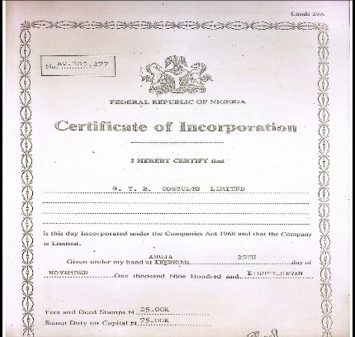
2.6 NOTABLE PROJECTS
Over the years, GYB Consults Nigeria Limited has built a diverse project portfolio, including:
- Weslet chapel Methodist church lekki, Lagos state.
- National Bank Headquarters ,Marina,lagos state.
- Office for First Bank of Nigeria Plc,Abeokute, Ogun state
- Design and reconstruction of the Pink & Blue House,Art Studio and rehearsal place.
- Cowrie Creek Project ,ikoyi,lagos state
- Factory for cheese Products Industries,Isolo,lagos state.
- Ereko Methodist church ,Ereko
- Conference Hotel Development,Abeokuta ,Ogun state
At the time of my training, the firm was also engaged in the proposed development of lagos state theatre at oregun, alongside proposed 15 stories residential apartments at Victoria Island ,renovation & redesign of a residential duplex at ijebu ode, finishing of 2 bedroom bungalow at kobape, giving me the opportunity to observe projects at multiple different stages of the design and construction pipeline simultaneously.
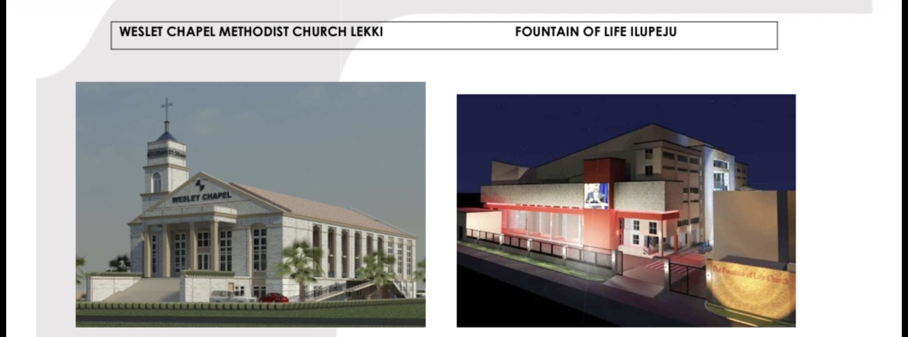
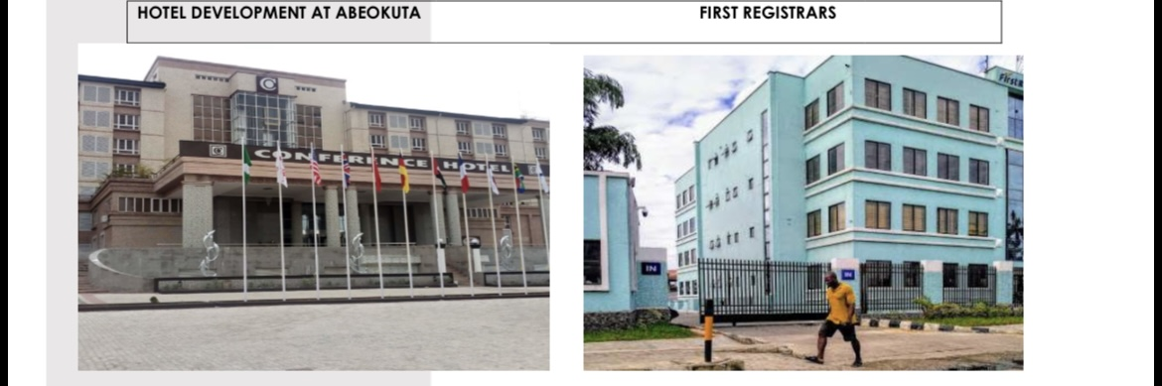
CHAPTER 3

3.0 CONSTRUCTION SITE EXPERIENCE
A significant part of my training involved direct exposure to active construction sites, where I observed how architectural drawings and specifications are translated into physical structures . This site experience gave me a far more concrete understanding of construction sequencing, coordination, and the practical challenges that arise between design intent and site execution.

3.1 OVERVIEW OF SITE WORKS
In construction, site works encompass all activities related to preparing and shaping a project's physical site, from initial surveying and excavation through to utilities installation, concrete works, and eventual landscaping. Site works play a crucial role in the smooth progress of a project, laying the groundwork (often literally) for everything that follows, from the building's shell through to its interior fit-out.

3.2 CASTING
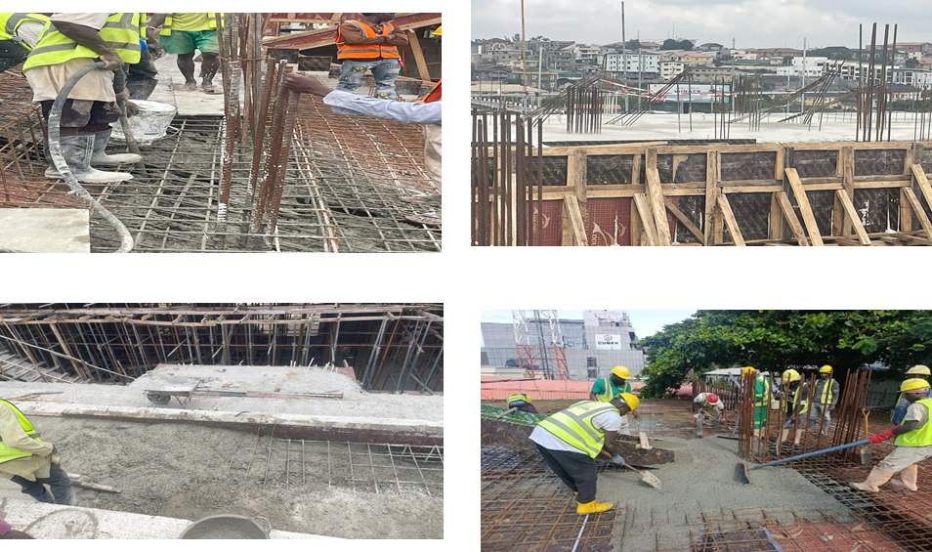I was tasked with ensuring appriopriate cement mix ratio as approved by the structural engineer for the casting of floor slabs . This stage is a critical checkpoint, any inaccuracy in casting carries through the entire construction process and observing and participating firsthand gave me a much clearer appreciation of why precision of appropriate cement ratio at this stage matters so much.

3.3 FORMWORKS
I participated and supervised the installation of formwork for various structural elements at the Oregun and V.I sites .I learned the importance of accurated levelling, proper propping and tight joints to ensure structural stability when casting and also to prevent concrete leakage .I was involved in erecting formworks for columns, beams and gallery seats which required stepped profiles ,adequate bracing and proper concrete cover. I worked closely with the surveyors who used theodolite to check levels.
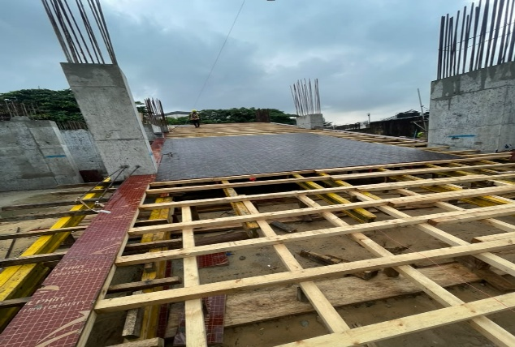
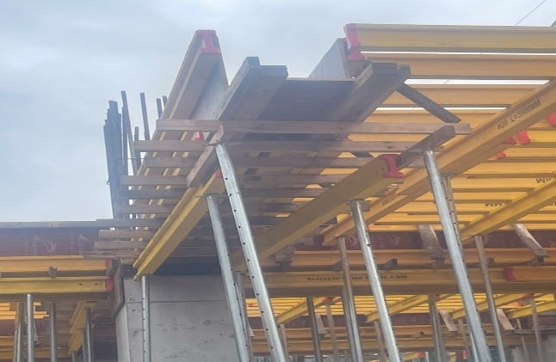
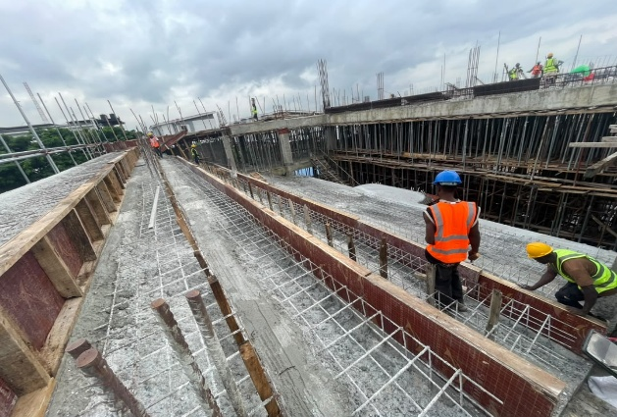
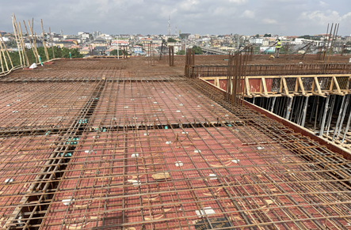

3.4 RAFT FOUNDATION
Among the more instructive site visits during my training was my trip to the proposed development at Oregun, Lagos, one of GYB Consults' ongoing projects at the time. Unlike the residential sites I had grown accustomed to around Arepo where I reside , most of which relied on strip foundations, this site introduced me to raft foundation construction, a system I had until then only encountered in textbooks.
Although I was not on site during the initial construction of the raft foundation at Oregun,I learnt about it through the discussions with the site engineers and surveyors on why raft foundation was chosen for this project. They explained that a
raft foundation was used because the lagos state theatre is a large, heavy structure with substantial column loads, gallery seating, and ramps and a raft spreads these loads uniformly over the entire building footprint. The soil also had a relatively low bearing capacity, so isolated pad footings would have been large, closely spaced and prone to differential settlement. The process began with site clearing and setting out by the surveyors followed by excavation to the design formation level. The base was then compacted and blinded with lean concrete and damp-proof membrane was laid over it. Edge formwork was installed and top and bottom reinforcement mats were fixed according to the structural drawings with spacers to maintain cover and starter bars left for the columns. After inspection and approval,concrete was placed continuously in layers,compacted with vibrators to avoid cold joints and voids, then levelled and cured for several days.
Speaking with the site engineers helped me understand the reasoning behind the choice of a raft foundation for this particular site, a decision driven largely by the soil conditions and the anticipated loading of the proposed structure, both of which made shallow foundation types unsuitable. This was a valuable lesson in itself: that foundation type is never a default choice, but a decision shaped by geotechnical investigation, structural load requirements, and site-specific constraints.
Through this experience and learning, I understood how structural loading, soil conditions and settlement control influence foundation selection and how accurate setting out,reinforcement placement and curing ensures strength and durability.

3.5 BUILDING RENOVATION
I inspected a renovation site at a Housing Estate, Kobape, Abeokuta where I witnessed the installation of 8 points of A/C, drainage pipes, excavator fan,passing of cables through 20mm pipes and the patching of roofing sheets and cracks around the house. This experience gave me insight into how existing structural defects are diagnosed, how their likely causes are assessed, and how repair works and modifications are planned and executed without compromising the safety of the rest of the structure.
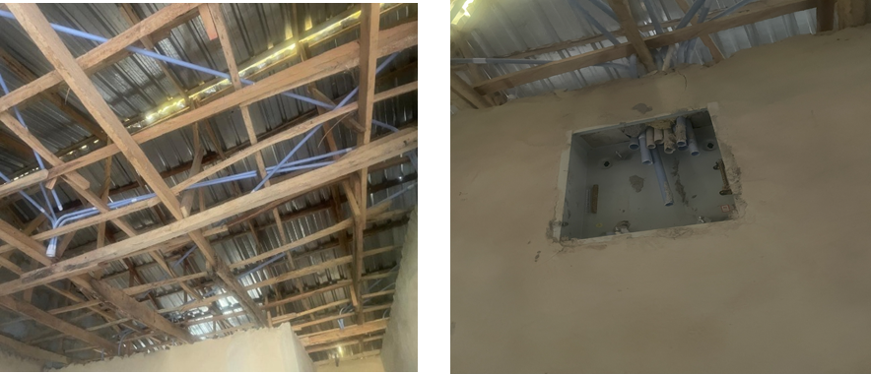
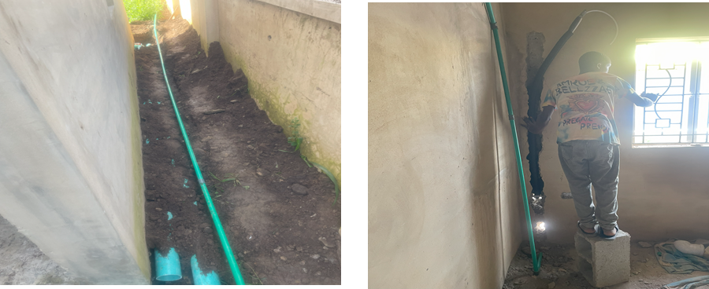

3.6 BUILDING MEASUREMENT AND BILLING
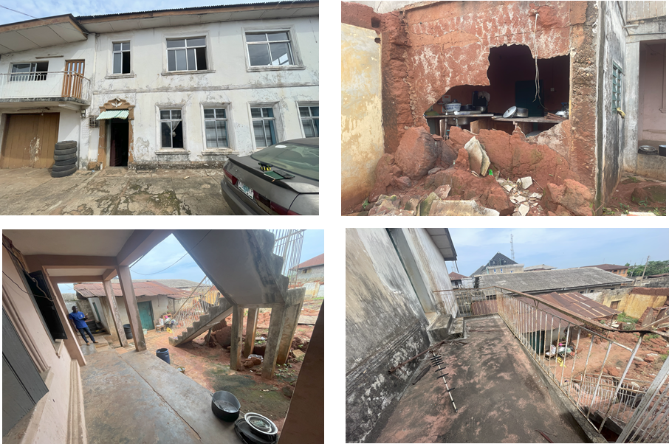I was assigned to design and take measurements along with the Quantity Surveyor for walls and doors to be broken at a Residential Duplex in Ijebu-Ode which gave me practical exposure to how completed works are quantified and valued for payment purposes. This gave me a working understanding of how the drawings and specifications produced in the studio ultimately connect to the financial and contractual side of a construction project.

3.7 REINFORCEMENT
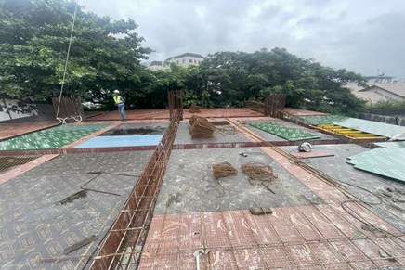
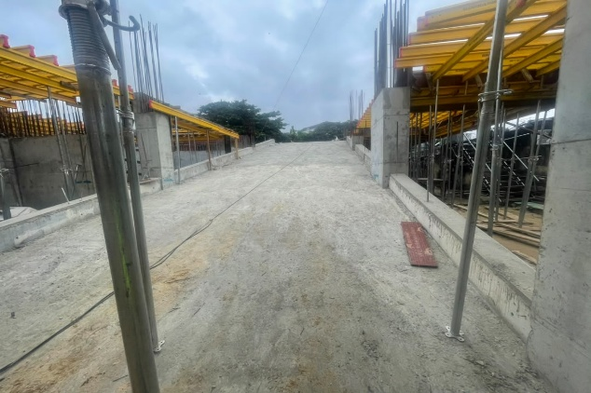
I observed a ramp and floor slab reinforcement work at a site at Victoria Island, gaining insight into how various sizes of reinforcement bars are positioned, spaced, and tied in accordance with structural specifications, and witnessed how the bars was shaped to follow the slope alongside additional support.

3.8 BEAMS AND COLUMNS

At the site in oregun and Victoria Island I observed an circular column and fixed beam, along with and other associated structural works. This deepened my understanding of how beams and columns function together within a building's structural frame, and how formwork is used to shape concrete elements before they are cast and cured.

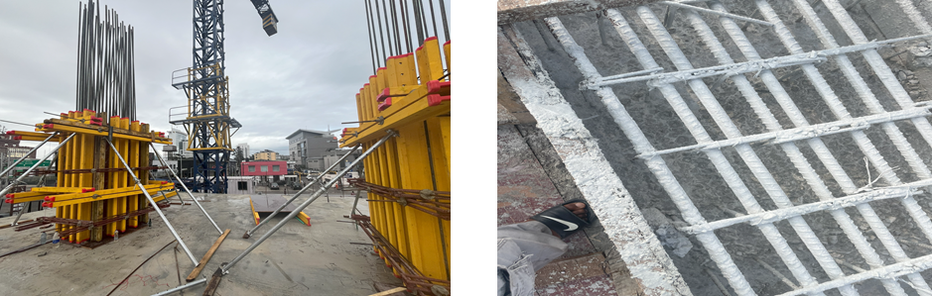

3.9 CONCRETE QUALITY CONTROL
I participated in the collation of results and filling of mold cubes with concrete for comprehensive strength testing. I gained practical knowledge of concrete quality control procedures and the role of laboratory testing in confirming that concrete meets the specified strength requirements.

3.10 BLOCKWORKS
Blockwork activities were observed at the Oregun site, including the lintel over openings and the construction of walls for the theatre project. I paid particular attention to marking of blocks lines, joints, block alignment, vertical plumb and how they were maintained and checked throughout the process.
placement of 9 inch blocks on ground floor laying of 9 inch blocks on first floor
placement of 9 inch blocks on ground floor finished blockwork

3.11 SITE MEETINGS
I attended several site meetings across various sites during my stint for the construction of the Lagos State Theatre at Oregun ,Ikeja , and the construction of a 15 storey Residential Apartment at Victoria Island,Lagos was subsequently involved in preparing the meeting minutes. This experience highlighted just how much of a construction project's success depends on clear communication and coordination among the various stakeholders including architects, engineers, contractors, and clients, and how meeting minutes serve as an important record of decisions and action points going forward.
.

3.12 CONSTRUCTION SITE SAFETY
Ensuring the safety of a construction site is a critical part of any construction-related activity, aimed at protecting workers and visitors from potential hazards including injury, illness, or worse. Safety practices are integral to every work environment, helping to prevent and mitigate accidents while supporting the wellbeing of everyone on site.
Throughout my site visits, I paid close attention to the following practices, which were consistently emphasized:
- Use of Personal Protective Equipment (PPE) at all times.
- Commencing work only after proper site induction.
- Keeping the site tidy to reduce potential hazards.
- Following posted safety signs and established work procedures.
- Taking personal responsibility for one's own safety and that of others nearby
- Reporting defects, hazards, or near-misses promptly.
- Never tampering with safety equipment or protective barriers.
- Maintaining clear and effective communication with the site team.
- Asking questions and seeking clarification whenever in doubt.

CHAPTER 4

4.0 STUDIO EXPERIENCE AND DESIGN/DOCUMENTATION SOFTWARE
My office-based responsibilities at GYB` Consults Nigeria Limited involved architectural design, drafting, and documentation work using industry-standard software. This exposure strengthened both my technical software proficiency and my understanding of how a design moves from initial concept sketches through to construction-ready documentation. Working in the studio also gave me a much clearer sense of how design decisions are shaped by practical constraints such as client budget, site conditions, structural feasibility, and regulatory requirements, rather than by aesthetics alone.


4.1 AUTOCAD
AutoCAD was used extensively for architectural drafting. During my training, I worked on polyline and roof-drawing exercises, which helped build my precision and speed in 2D technical drawing and reinforced my understanding of drafting conventions used for construction documentation and dimensioning.

4.2 REVIT

Revit, a Building Information Modelling (BIM) software, was central to much of my studio work. I used Revit in the development of renovation of a duplex at ijebu ode and in preparing working drawings for a 2 Bedroom bungalow, gaining experience in model-based design, scheduling, and documentation. Working with Revit's parametric modelling environment also taught me how changes to a single element automatically propagate across an entire drawing set, which underscored the importance of building models correctly and consistently from the outset.


4.3 LUMION
Lumion was used for architectural visualization, allowing design ideas to be presented to clients and stakeholders in a realistic, immersive format that aided decision-making and communication. I came to appreciate how a well-produced visualization can bridge the gap between a technical drawing, which a client may struggle to read, and a real understanding of what a finished space will actually look and feel like.

4.4 THEORETICAL KNOWLEDGE GAINED DURING THE INTERNSHIP

4.4.1 ROLES OF PROFESSIONALS IN THE CONSTRUCTION INDUSTRY
The construction industry is inherently collaborative, requiring the coordinated input of several professionals, each with a distinct area of responsibility:
Architects are licensed professionals trained in both the artistic and technical aspects of building design. They conceptualize and develop plans for structures, ensuring designs are functional, safe, cost-effective, and responsive to user needs, while adhering to relevant codes, zoning laws, and safety regulations. Their responsibilities often span the full project lifecycle, from client consultation and feasibility studies through to detailed design and construction oversight.
Quantity Surveyors are experts in estimating and managing construction costs. They assess the labor, materials, and equipment required for a project, working to ensure it is completed within budget while maintaining the specified quality standards.
Engineers including structural, civil, and mechanical engineers, ensure the technical soundness of a design. They translate architectural intent into structurally sound, code-compliant systems, providing the technical backbone that makes a design buildable and safe.
Building Contractors oversee the physical execution of construction, managing labour, coordinating tasks, and ensuring that work is carried out according to the approved project plan and within regulatory requirements.
The Clerk of Works is responsible for verifying that construction is carried out according to specifications and quality standards, conducting regular site inspections to confirm that materials, workmanship, and safety practices meet the required benchmarks.
The Client is the individual, organization, or entity commissioning the project, ranging from private individuals to institutional bodies or property developers, whose brief and budget shape the entire direction of the work.

4.4.2 PROJECT MANAGEMENT
Construction project management involves coordinating resources including time, money, materials, equipment, and personnel, to complete a project on schedule and within budget. It requires close collaboration among the professionals listed above to manage every phase of the building lifecycle, from initial planning through to completion, while balancing client needs, stakeholder expectations, and site or environmental constraints. Observing this coordination in practice at IBW Consults, particularly during site meetings, gave me a much more concrete understanding of project management than I had gained from classroom instruction alone.

4.5 STUDIO PROJECTS

A. IJEBU- ODE DUPLEX
Project Type: Residential project.
Project Role: Building renovation floor plans, preparation of bill, sections, construction details, and design revisions
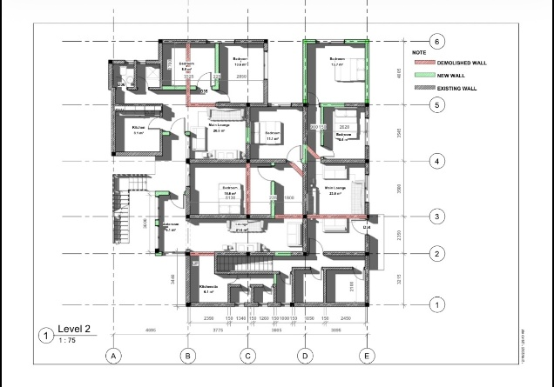
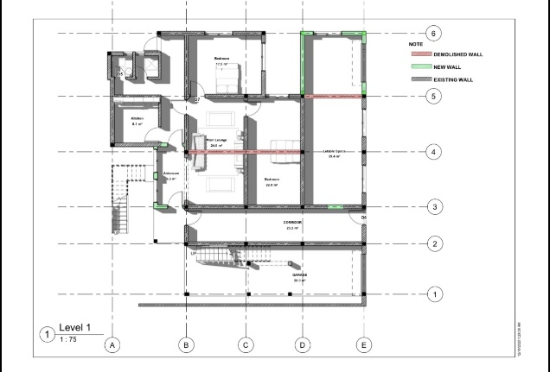
Project Description: I was involved in the renovation of a residential duplex of a from the building’s measurement , contributing to the layout of floor plans for the revised purpose and working closely with the Quantity surveyor. As the design progressed, I worked on producing construction details to support the working drawing package, and assisted in incorporating revisions as feedback was received which is an experience that taught me how a design is rarely finalized in a single pass, but refined iteratively as constraints and preferences are clarified. This visit directly connected my studio-based documentation work to what was actually happening on the ground, helping me appreciate how carefully a working drawing needs to be prepared in order to be correctly interpreted and executed by the construction team
Deliverables: Floor plans, construction details, and revised drawing sets reflecting design feedback.

B. 2 BEDROOM BUNGALOW
Project Type: Residential project
Project Role: Design development, floor plans, elevations, sections, construction details, and design revisions
Project Description: I was involved in the design development of a two -bedroom bungalow in Surulere from an early stage, contributing to the layout of floor plans and the development of elevations and sections. As the design progressed, I worked on producing construction details to support the working drawing package which I carried out according to the client’s preference.
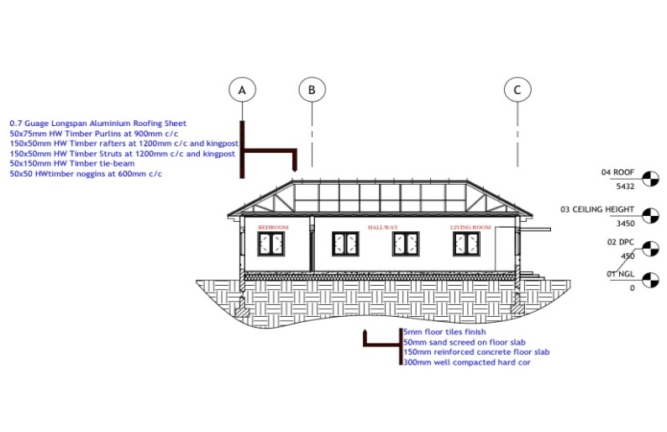
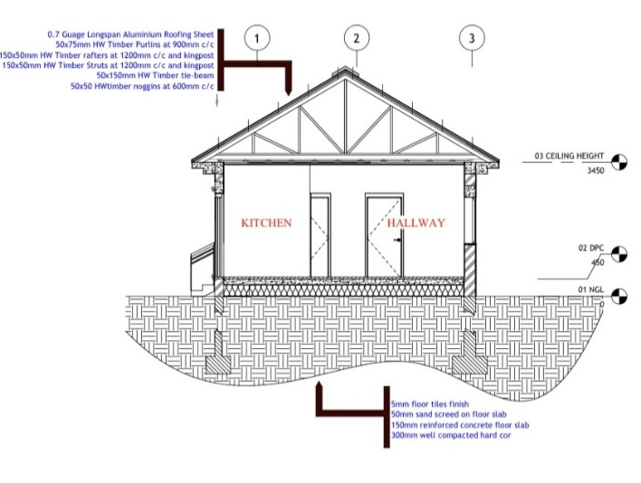
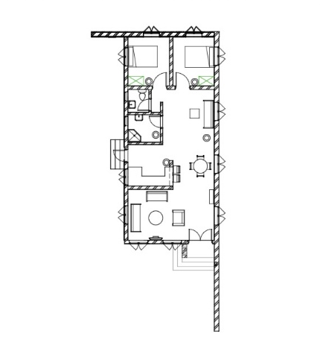
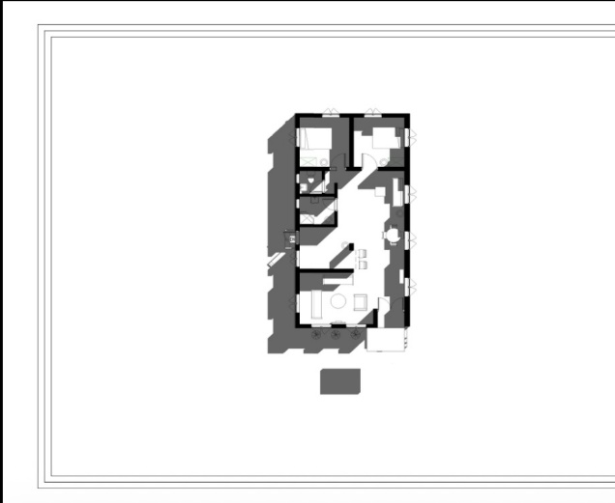

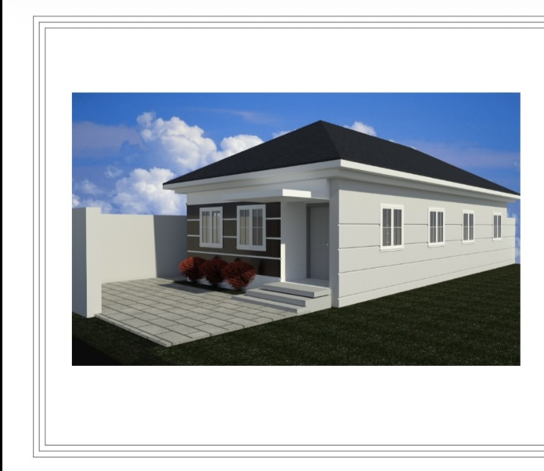
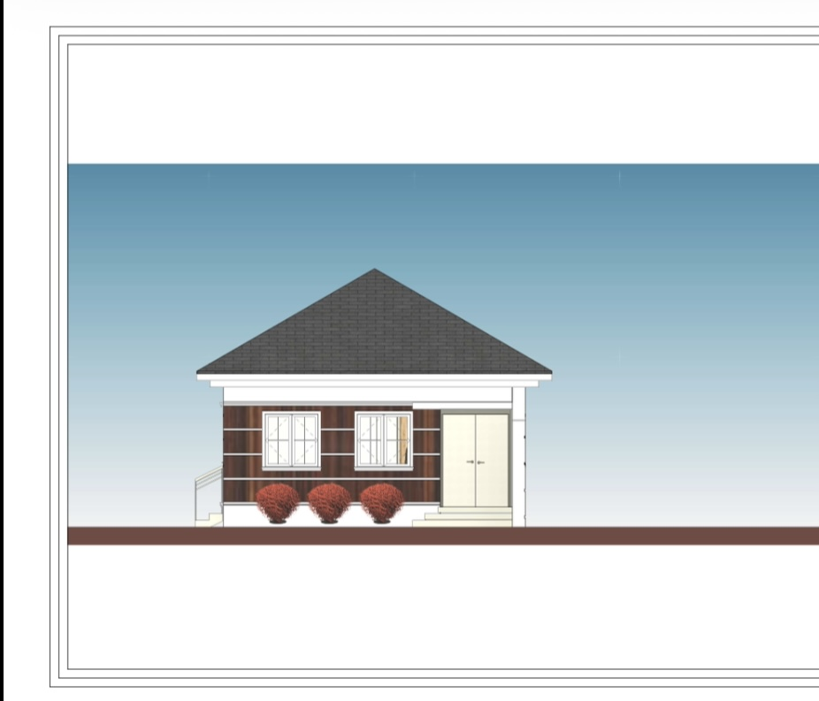
Deliverables: Floor plans, elevations, sections, construction details, and revised drawing sets reflecting design feedback

C. MANSIONETTE BUILDING
Project Type: Residential
Project Role: Preparation of working drawings using Revit
Project Description: I developed working drawings for the mansionette building using Revit, translating the approved design into detailed, construction-ready documentation. This involved ensuring that the model was accurately dimensioned and annotated so that it could be reliably used on site by the construction team.
Deliverables: A working drawing set produced in Revit for construction use.
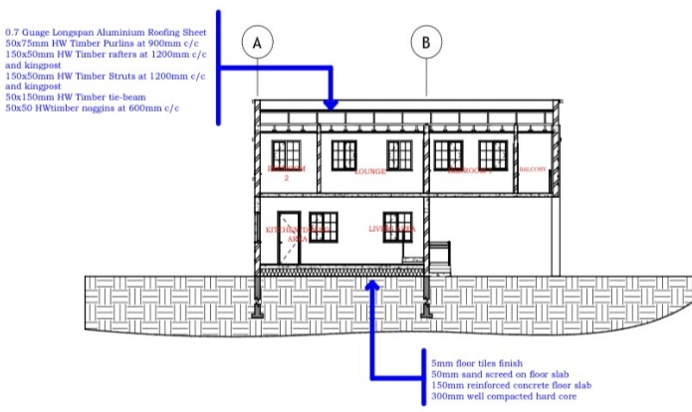

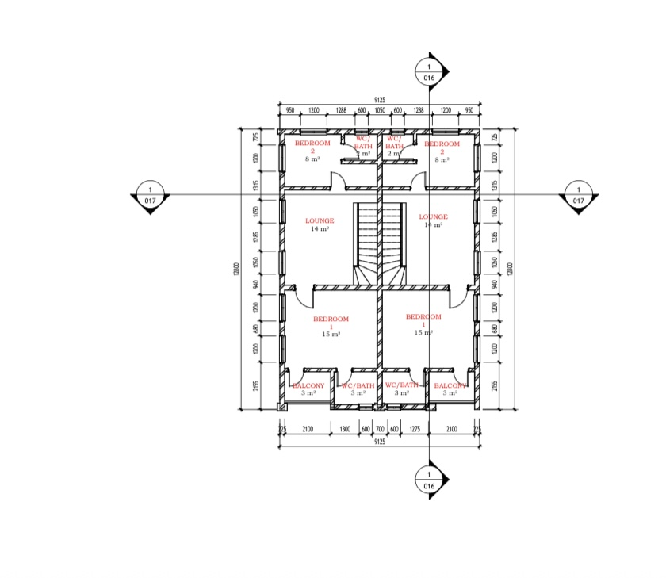
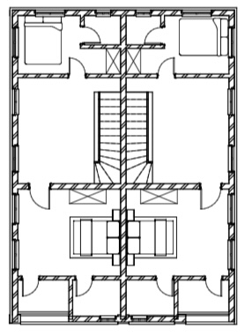
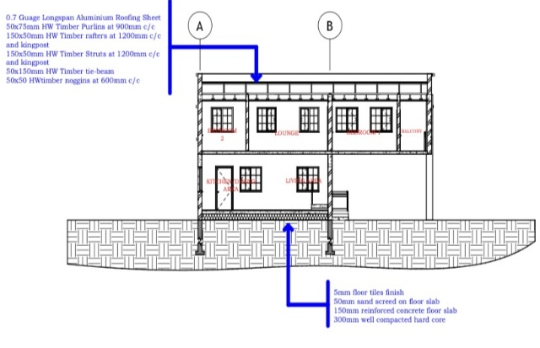
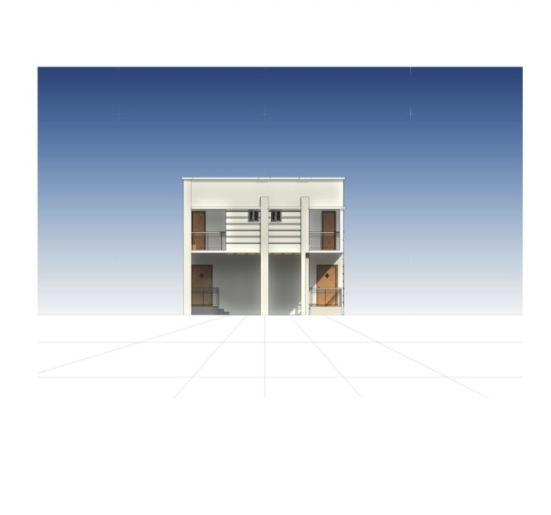
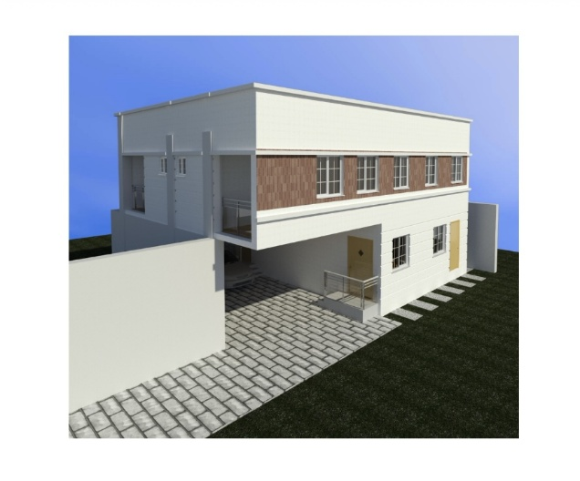

D. AACE ADMIN BLOCK
Project Type: Commercial
Project Role: Design development, floor plans, elevations, sections, construction details, and design revisions
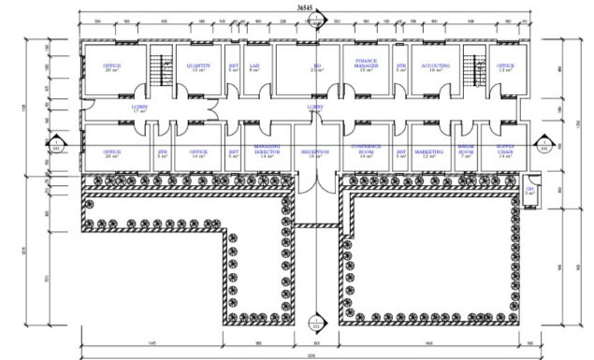
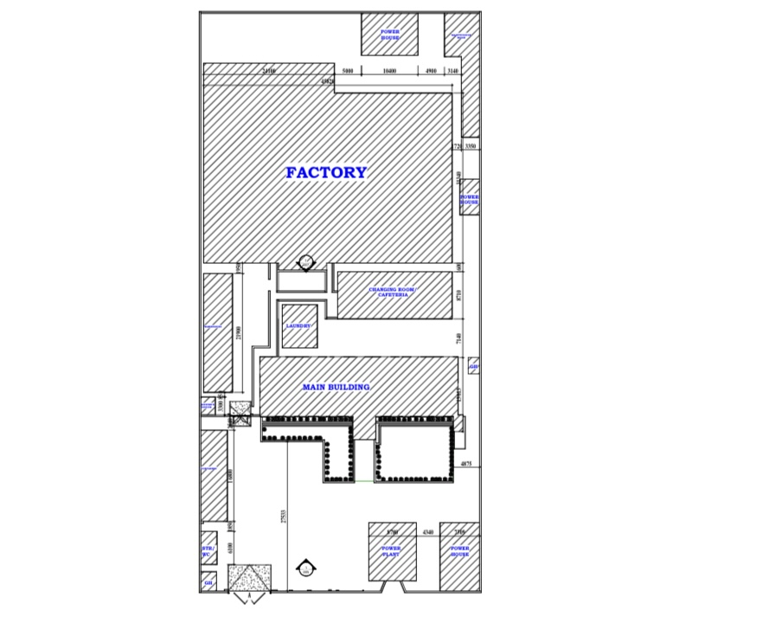
Project Description: I developed working and presentation drawings for the AACE Foods ltd’s Admin block using Revit, translating the approved design into detailed, construction-ready documentation. I made use of the site layout to help understand the positioning and orientation of the building to help serve its users efficiently. This involved ensuring that the model was accurately dimensioned and annotated so that it could be reliably used on site by the construction team.

.

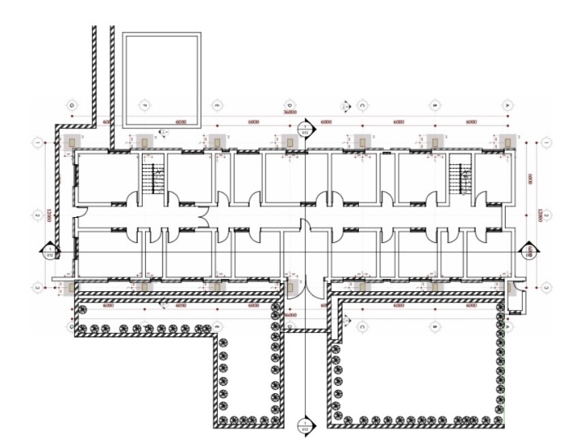
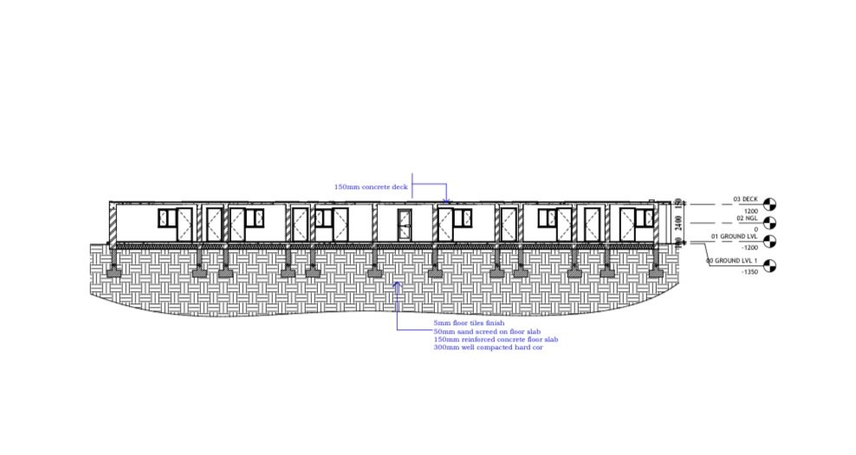
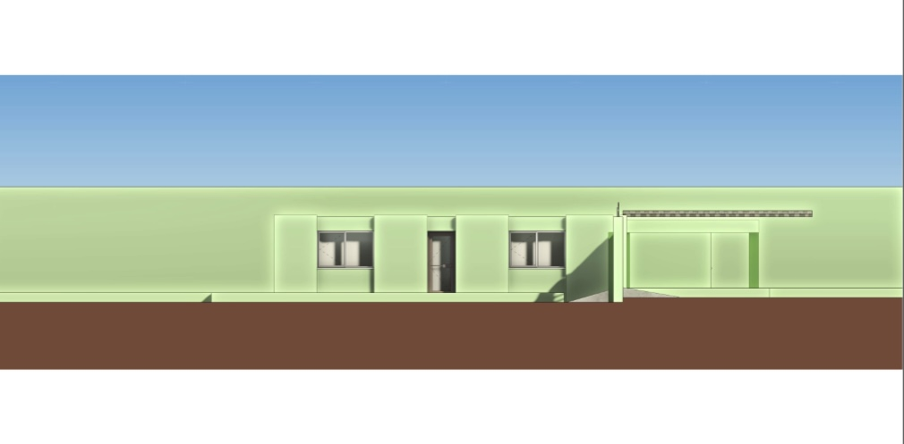
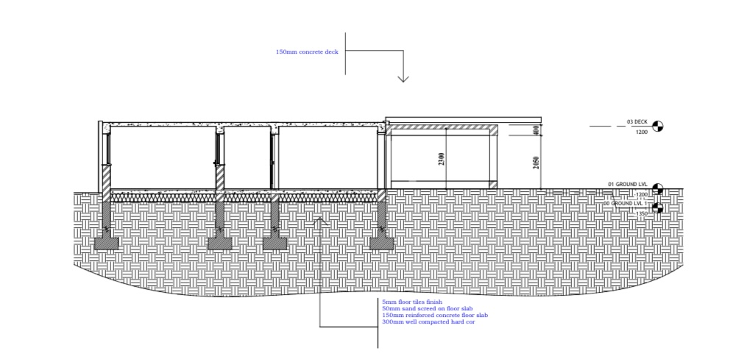

Deliverables: A working and presentation drawing set produced in Revit for construction use.

CHAPTER 5

5.0 SUMMARY OF TRAINING EXPERIENCE
My SIWES training at GYB Consults Nigeria Limited gave me balanced exposure to both the studio and site sides of architectural practice. In the studio, I improved my skills in AutoCAD, Revit, and Lumion while contributing to real design and documentation work on residential and commercial building projects, from early concept development to construction-ready working drawings. On site, I gained direct experience of construction sequencing, from foundation work through blockwork, reinforcement, structural framing, and renovation, along with the coordination, documentation, and communication that keep a project moving from one stage to the next.
Most importantly, the training showed me that the studio and the site are not separate disciplines but two ends of one process. A drawing prepared in the studio only becomes valuable when it can be properly read, interpreted, and executed on site, and my site experience gave me a clearer understanding of how to produce documentation that works in practice.
.
5.1 SKILLS ACQUIRED

• Architectural design and production of working drawings
• AutoCAD drafting, including polyline and roof-drawing techniques
• Revit modelling, scheduling, and preparation of construction documents
• Lumion rendering and client-oriented presentation
• Reading and interpretation of architectural and structural drawings
• Setting-out and foundation-related site activities
• Working knowledge of blockwork, reinforcement, beams, and columns
• Identification and repair of structural defects during building renovation
• Attendance at, and minuting of, professional site meetings
• Building measurement and billing procedures
• Awareness and practice of construction site safety

5.2 PROBLEMS/CHALLENGES FACED DURING TRAINING

• Applying theoretical knowledge to practical situations: Some concepts learned in the classroom had to be genuinely adapted when applied to real site conditions, sequencing, and constraints that a textbook example rarely reflects.

• Getting familiar with construction processes and professional documentation: Early in the training, it took time to adjust to site terminology, established procedures, and professional documentation practices, particularly during my first few weeks.
Although these challenges were uncomfortable at first, they contributed significantly to my adaptability and professional growth throughout the training period.

These challenges, while initially uncomfortable, ultimately contributed meaningfully to my adaptability and professional growth over the course of the training period.

5.3 RECOMMENDATIONS
Based on my experience, I would make the following recommendations to improve the SIWES program for future participants:
• Students should be given adequate exposure to both office (studio) and site-based duties during placement, as each develops a distinct but complementary set of skills.
• Practical training should be better aligned with classroom instruction, so that theoretical concepts are reinforced by, rather than detached from, what students experience on placement.
• Students should be encouraged to develop working proficiency in industry-standard architectural software, especially AutoCAD and Revit, before their SIWES placement, so that placement time can be devoted to more advanced, project-specific learning.
• Students should have more opportunities to take part directly in professional meetings and site supervision activities, as these develop communication and coordination skills that are difficult to teach in a purely classroom setting.
• Institutions should maintain closer supervision of, and communication with, host firms throughout the placement period, to ensure that students receive meaningful guidance and are assigned tasks suited to their level of training.

5.4 CONCLUSION

The SIWES program at GYB Consults Nigeria Limited gave me a truly valuable, hands-on introduction to professional architectural practice. Throughout my training, I gained experience in architectural design, computer-aided design and visualization, and a broad range of construction site activities, from foundation work through to blockwork, reinforcement, structural framing, renovation, and formal site meetings. This experience considerably strengthened my technical and professional competencies and gave me a clearer, more practical understanding of how design and construction come together, beyond what classroom instruction alone could provide.

I leave this training with greater confidence in my technical abilities, a stronger appreciation for the collaborative nature of the construction industry, and a solid foundation to build on as I move toward professional practice. It is recommended that the SIWES program continue to be supported, monitored, and improved, so that future students gain the same or even greater value from their own placements.

5.6 REFERENCES

• Chudley, R. and Greeno, R. (2016) . Building Construction Handbook (11th ed.). Routledge, London.
• Ching, F. D. K. (2014). Building Construction Illustrated (5th ed.). John Wiley & Sons, Hoboken, New Jersey.
• Neufert, E. and Neufert, P. (2012). Architects’ Data (4th ed.). Wiley-Blackwell, Oxford.
• Industrial Training Fund (ITF). SIWES Operational Guidelines. Industrial Training Fund, Jos, Nigeria.
• GYB Consults Nigeria Limited (2026). Company’s Profile.
• Department of Architecture (2025). Guidelines for Students Industrial Work Experience Scheme (SIWES). Federal University of Technology, Akure.

